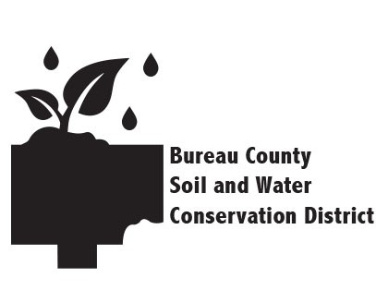
Bureau County Soil & Water Conservation District
2025 SCHOLARSHIP APPLICATION

Sponsor: This award is sponsored by the Board of Directors of the Bureau County Soil & Water Conservation District.

Purpose: This scholarship has been established by the Bureau County Soil & Water Conservation District (BCSWCD) to assist outstanding students in obtaining a college education. The student awarded the scholarship should demonstrate commitment to soil and water conservation and potential for innovation and leadership ability.

Eligibility: Any student who is a high school senior or current college student and is seeking to obtain a degree in a natural-resource related field (agriculture included) is eligible for nomination.

Selection Process & Award: Annually, one student in Bureau County will be chosen by an appointed committee within BCSWCD to receive this award. A $1,000 scholarship will be awarded to the student after their first semester of college has been successfully completed.

Deadline: This application form and all other required documentation must be received by Friday, April 25th, 2025.

Mail application to: Bureau County SWCD
312 E. Backbone Rd.
Princeton, IL 61356
OR Email: bureaucountyswcd@gmail.com

Questions? Call (815) 875-8732 ext. 3; or send us an email.

Application:
Required fields are indicated by an asterisk (*).

- Eligibility. Students must meet these criteria to be eligible. Please initial.

____* I confirm that I am a current resident of Bureau County, Illinois.

____* I am currently a high school senior and will be attending a 2-yr or 4-yr college
in the fall of 2025 as a full-time student.
OR
____* I am currently a full-time college student and will be attending a 2-yr or 4-yr college in the fall of 2025.

____* I intend to enroll (or am currently enrolled) in a natural resource-related
degree program.
*I will be (or am) enrolled in the following program(s) (check all that apply):
      - Forestry
      - Geography
      - Environmental Science
      - Natural Resources
      - Ecology
      - Soil Science
      - Agriculture
      - Other: ________________________

- Personal Information.
  - *Name
First name*-- Middle name(s) -- Last name*:

_____________________________________________________________

  - *Home address

*Address: _____________________________________________________

*City: _________________________ *State: _____ *ZIP: ______________

  - *Primary telephone: ___________________________________________

  - Secondary telephone: __________________________________________

  - E-mail: ______________________________________________________

  - *Date of Birth (MM/DD/YYYY): _______/ _______/ _________

- Academic Information.
  - *What school do you currently attend?

*Name: ______________________________________________________

*What is your current GPA?: __________

  - *What college will you attend in 2025-2026?

Name:__________________________________________________

City: _______________________ State: _____ , or,

Undecided. Colleges under consideration are:

_____________________________________________________

  - *What profession or field of employment do you wish to enter with your college degree?

_____________________________________________________________

  - *Anticipated year of college graduation: ___________________________

- Supplemental Materials.

  - *Proof of Grades: Submit a current copy of your high school transcript. Also, submit a current copy of your college transcript(s), if applicable.

  - *Essay Questions:

- Describe your past and current extracurricular and/or community activities, including offices held.
- State your educational plans and career objectives for the next 5 years.
- Elaborate on your interest and/or experience in soil and water conservation activities.

*Certification Statement:
By signing my name below, I confirm that all the information provided above and in the accompanying documents is true and correct to the best of my knowledge.

Signed:___________________________________Date:_______________________

